CLOUD DEVELOPMENT B

POE PART 3

**Azure SQL Database**

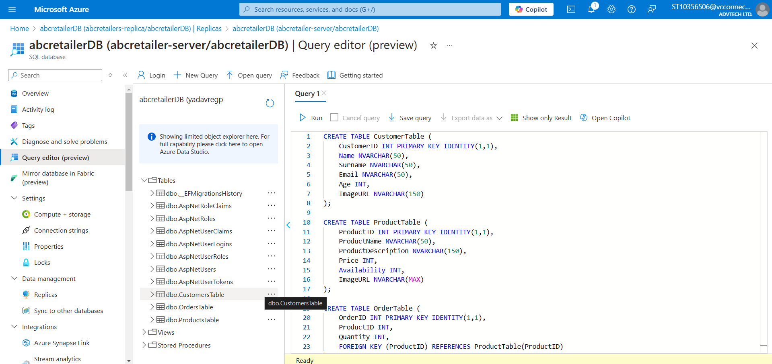

Database created with tables.

**Creating a replica of the ABC Retailers Database (Biqian, 2024)**

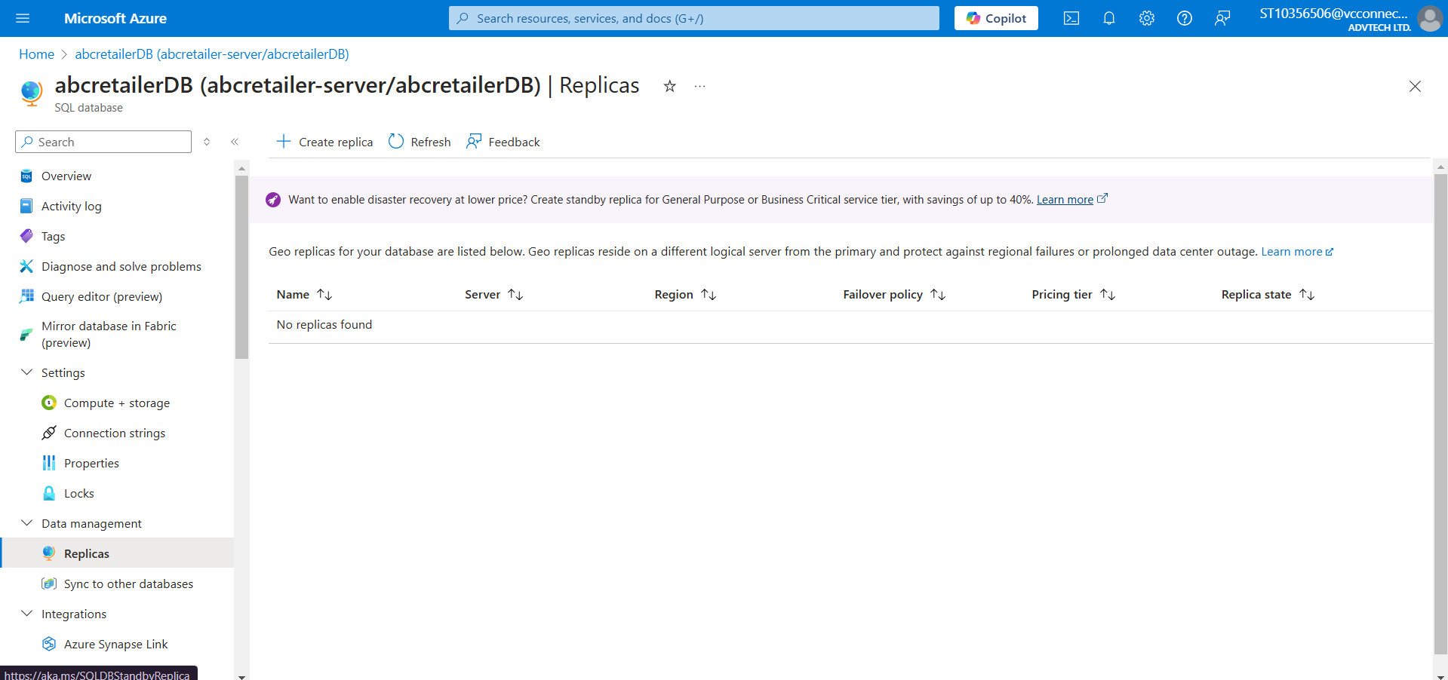

Started off with no replicas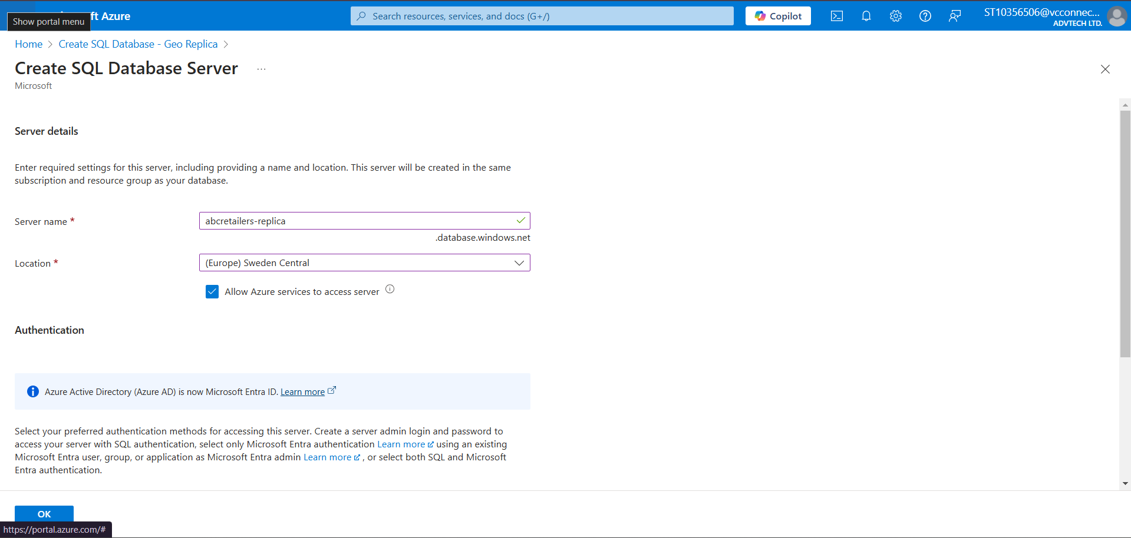

Created a new SQL Database server with a different region.

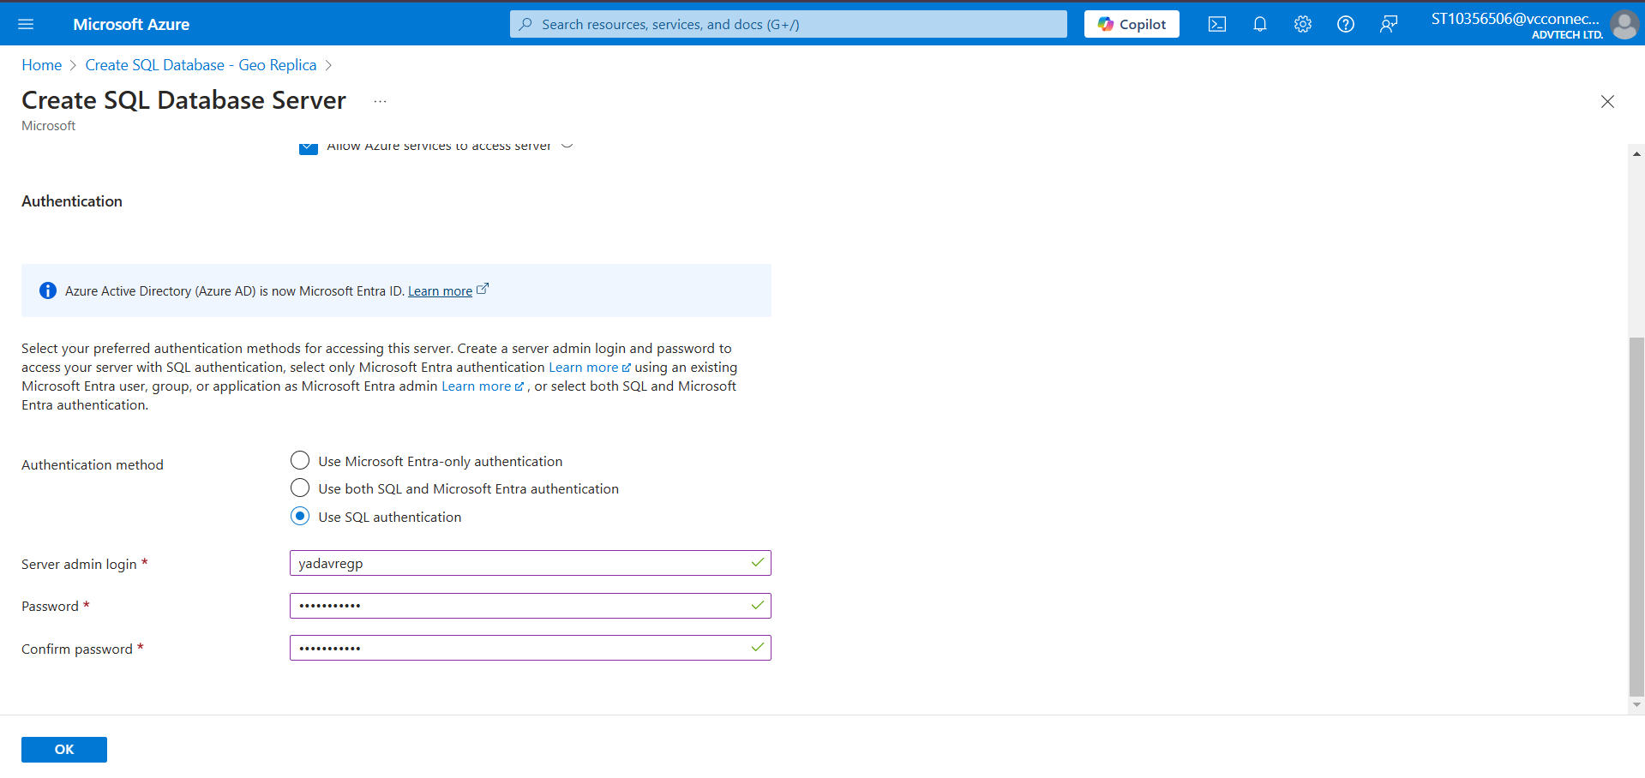

Configuring the new database

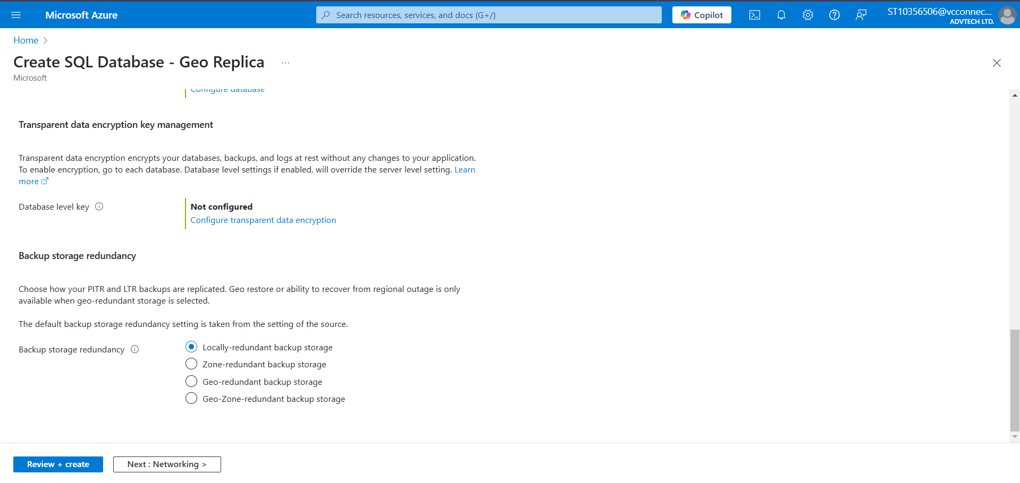

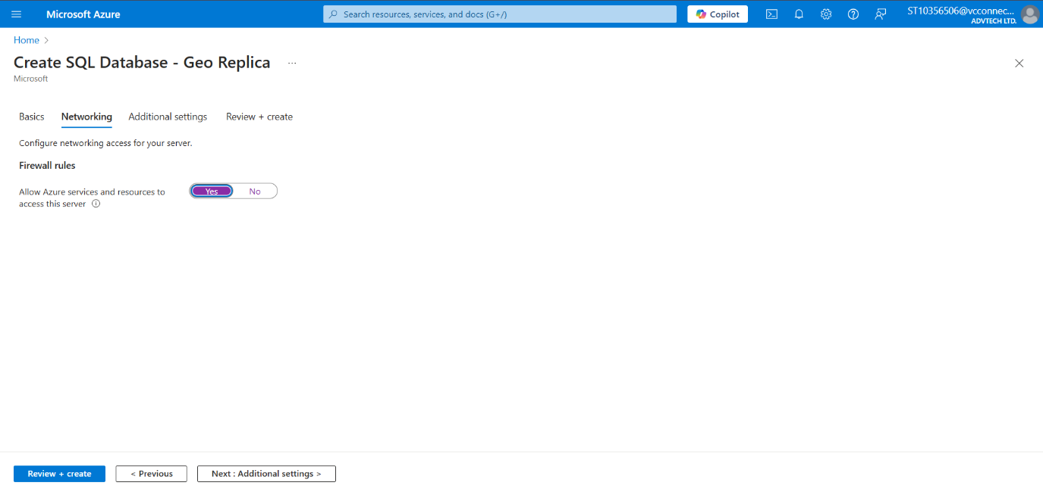Configuring the firewall rules.

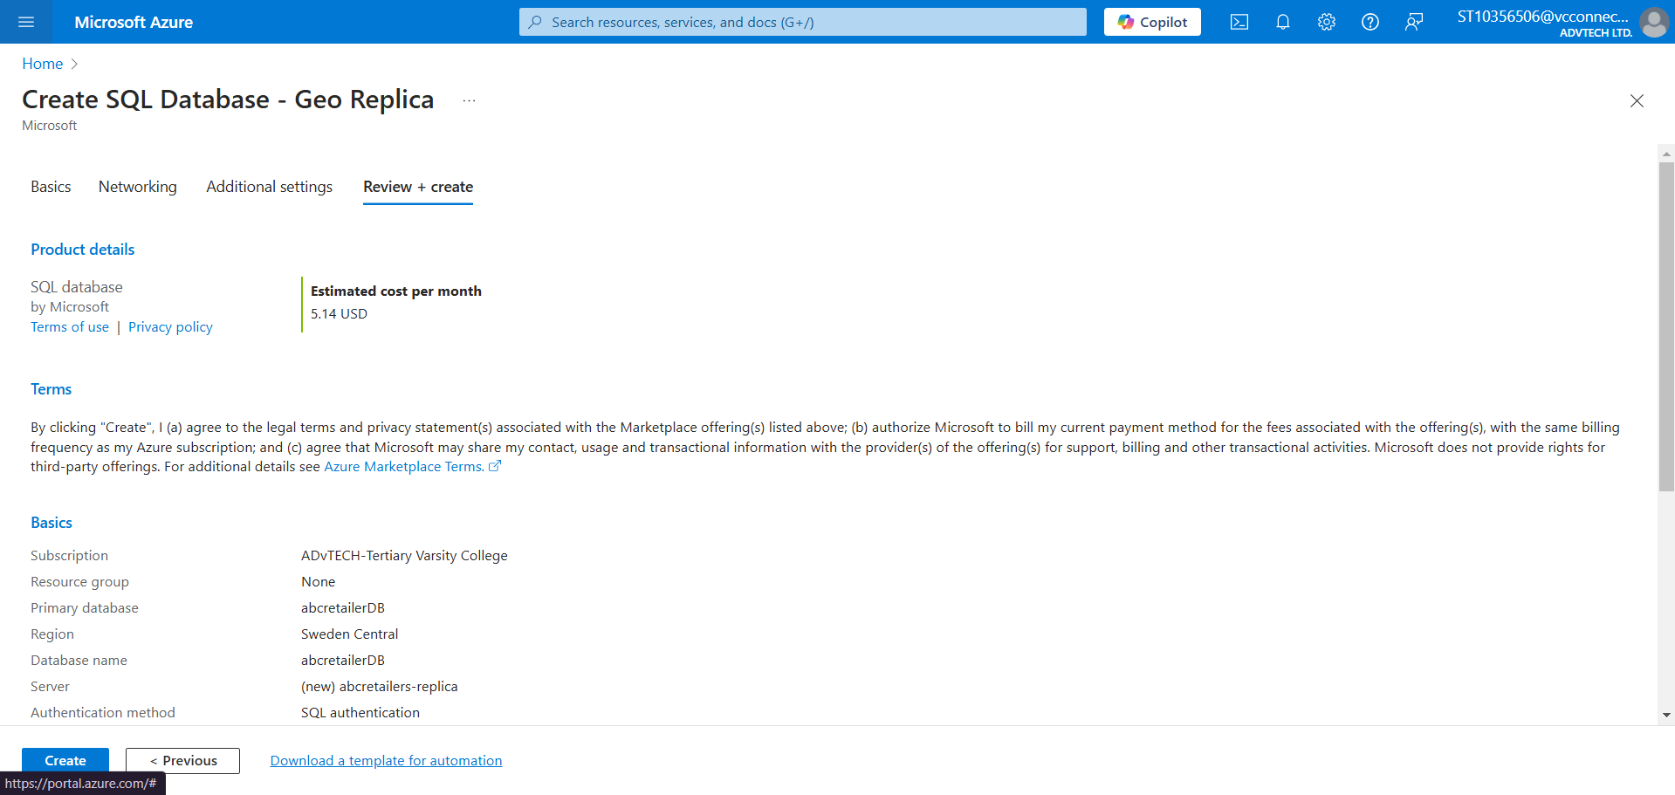

Creating the Replica

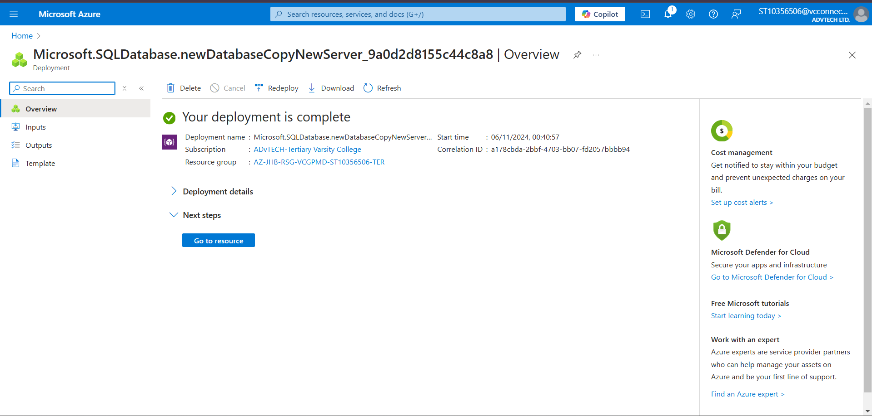

Successful deployment of replica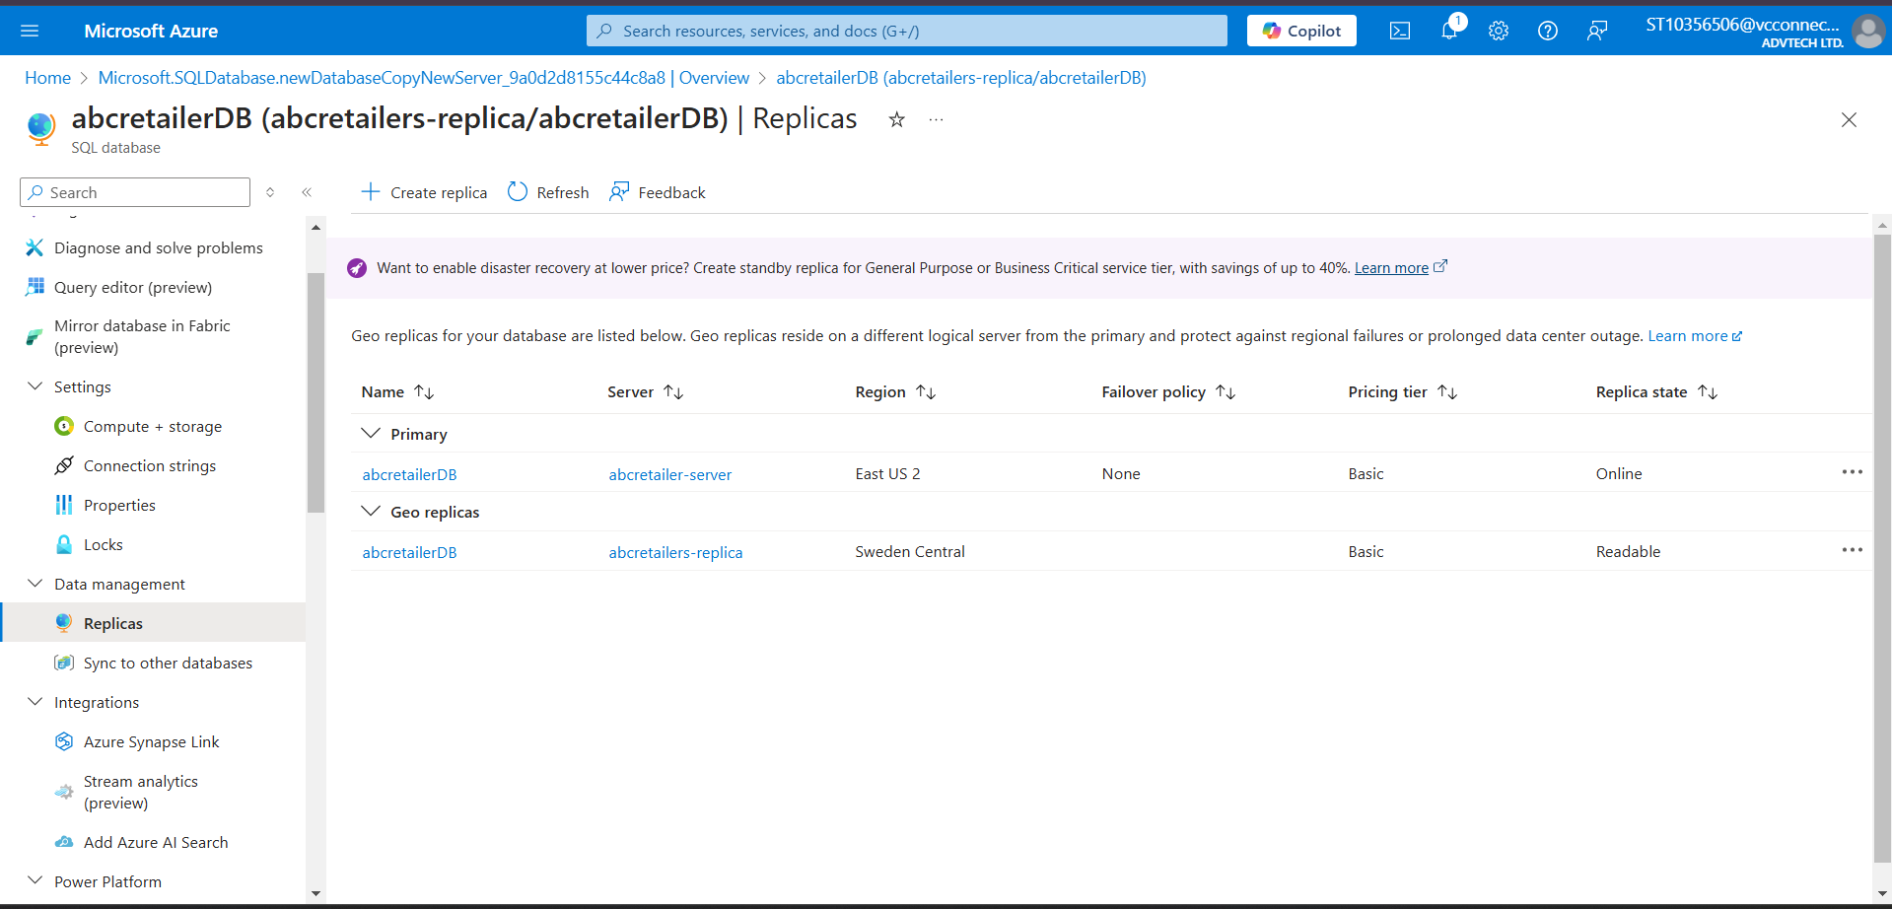

Replica now displaying in the list

**All resources in Azure**

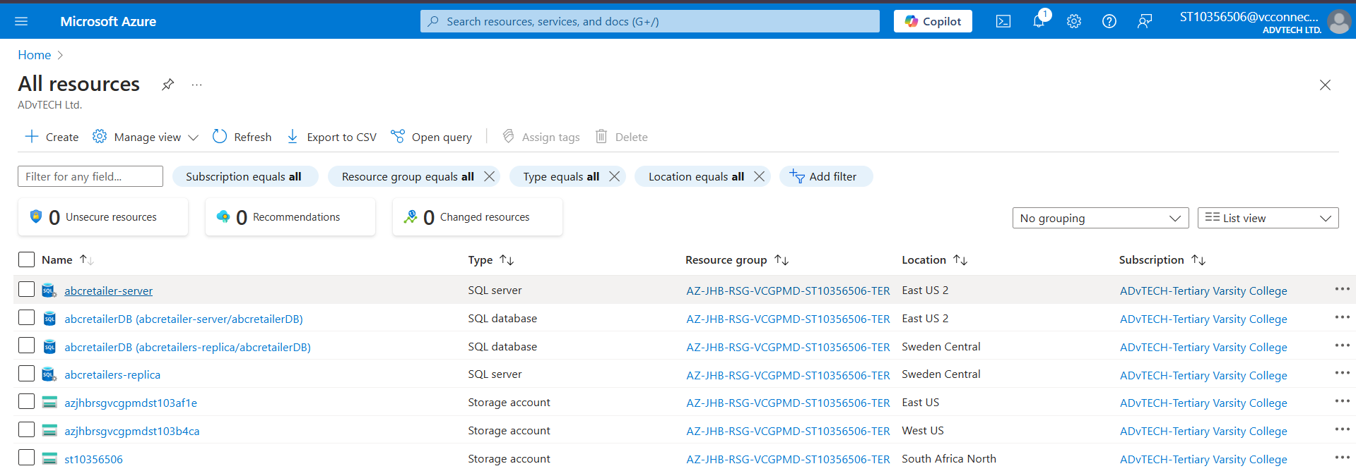

**Why create a replica?**

Geo-replication is a strategic approach for providing solutions to businesses that support business continuity, user experience, and performance by: (anon, 2024)

* **Disaster recovery solutions:**

Geo-replication creates replicas of data and stores it across multiple databases in different regions which ensures quick recovery from potential data loss such as natural disasters, hardware failures, or data breaches. Regional redundancy ensures that if one region is compromised, data will still remain accessible from other regions which promotes business continuity. (Khabarati, 2024)

* **Improved user experience**

Geo-replication allows users to store their data in a region closest to them which reduces data upload and access time by reducing latency which in turn improves responsiveness of the application. (anon, nd)

* **Enhanced performance**

Geo-replication allows for data to be distributed to various regional databases which improves load balancing during peak time which improves performance. (Khabarati, 2024)

* **Availability**

Geo-replication promotes business uptime and availability by providing redundancy which allows data to still be accessed by another region as a backup if the primary region is compromised. (Marget, 2024)

**Technology choices used**

**Table documenting the components, technology used, hosting model, and descriptions of each component used.**

|  |  |  |  |
| --- | --- | --- | --- |
| **Component** | **Technology Choice** | **Hosting Model** | **Description** |
| Azure Table Storage  (Akashdubey-Ms, 2022) | Data Storage(structured data) | PaaS | Used to store large amounts of structured data such as text files, user information |
| Azure Blob Storage  (Akashdubey-Ms, 2023) | Object Storage (unstructured data) | PaaS | Used to store unstructured data such as multimedia files. |
| Azure Queue Storage  (Normesta, 2023) | Message Storage | PaaS | Used to reliably store messages for processing data asynchronously. |
| Azure FileShare Storage (Khdownie, 2023) | File Storage | PaaS | Used to share and store files through the application. |
| Azure SQL Database  (WilliamDAssafMSFT, 2024) | Relational Database | PaaS | Provides a relational database that is ideal for storing structured data which can be created, viewed, updated, and deleted through a connected application. |
| Azure App Service (Msangapu-Msft, 2024) | Application Hosting | PaaS | Used to deploy a web application once it has been developed. |

**Motivation for Technology Used**

**Table describing how the used services were used in the application.**

|  |  |  |
| --- | --- | --- |
| **Azure Service** | **Application Requirement** | **Motivation** |
| Azure Table Service  (Akashdubey-Ms, 2022) | Storing customer and product information such as customer name and product description. | Table Storage provides a quick, scalable, and easy way to store an applications structured data cost effectively and securely. |
| Azure Blob Service  (Akashdubey-Ms, 2023) | Storing multimedia files such as customer profile pictures and product images. | Blob Storage is ideal for storing and retrieving unstructured data such as image files as it is cost-effective, scalable, and secure. |
| Azure Queue Service  (Normesta, 2023) | Sending real-time updates to the inventory to log the remaining availability of a product a user has purchased. | Queue Storage is essential for processing orders by sending messages to the applications storage location without hindering the performance of the application. |
| Azure FileShare Service (Khdownie, 2023) | Sharing files to ABC Retailers through the application which can later be downloaded, viewed and deleted. | FileShare Storage is useful for sharing and storing files securely using the application. |
| Azure SQL Database (WilliamDAssafMSFT, 2024) | Used to store customer, product, and order information. | Azure SQL Database is suitable for storing and managing structured data efficiently and also allows it to be easily accessed through the application. |
| Azure App Service(Msangapu-Msft, 2024) | Used to deploy the application and make it publicly available. | Azure App Service is important for deploying your application and making it publicly available. Azure App Service also ensures that the deployed application is scalable, available at all times, responsive, and performing as it should. |

**Alternative Azure Technologies**

|  |  |  |  |
| --- | --- | --- | --- |
| **Current Service** | **Alternative Service** | **Requirement Satisfied** | **Motivation** |
| Azure Table Storage | Amazon DynamoDB (Williams, 2021) | Storing structured data such as user and product data. | Amazon DynamoDB is a better alternative to Azure Table Storage as it offers more scalability which adapts to your application, auto data replication, better security, and better performance. |
| Azure Blob Storage | Google Cloud Storage (Prakash, 2023) | Storing unstructured data such as customer and product images. | Google cloud storage would be a good alternative to Azure blob storage as it is more scalable and optimized for data-intensive workloads and offers multi-regional availability and security making it ideal for large data applications. |
| Azure FileShare Storage | Google Cloud FileStore (Mark, 2024) | Sharing and storing files through the application. | Google Cloud FileStore offers a greater advantage than Azure FileShare when it comes to performance as it provides a managed network-attached storage making it perform better for latency-sensitive workloads. |
| Azure Queue Storage | Azure Event Hubs(Spelluru, 2024) | Handling messages and updating inventory based on user interactions. | Azure event hubs is a good alternative to azure fileshare as it offers higher performance, is fully managed, available across multiple regions, and is more secure as it performs regular backups. |

**Changes based on lecturer feedback**

Based on the feedback provided from class discussions, I have ensured that all the components of the application now work as they should, the customer, product, and order information now get stored in the desired storage location (Azure SQL Database) and is retrieved and edited via the web application.

**Creating the web app service**

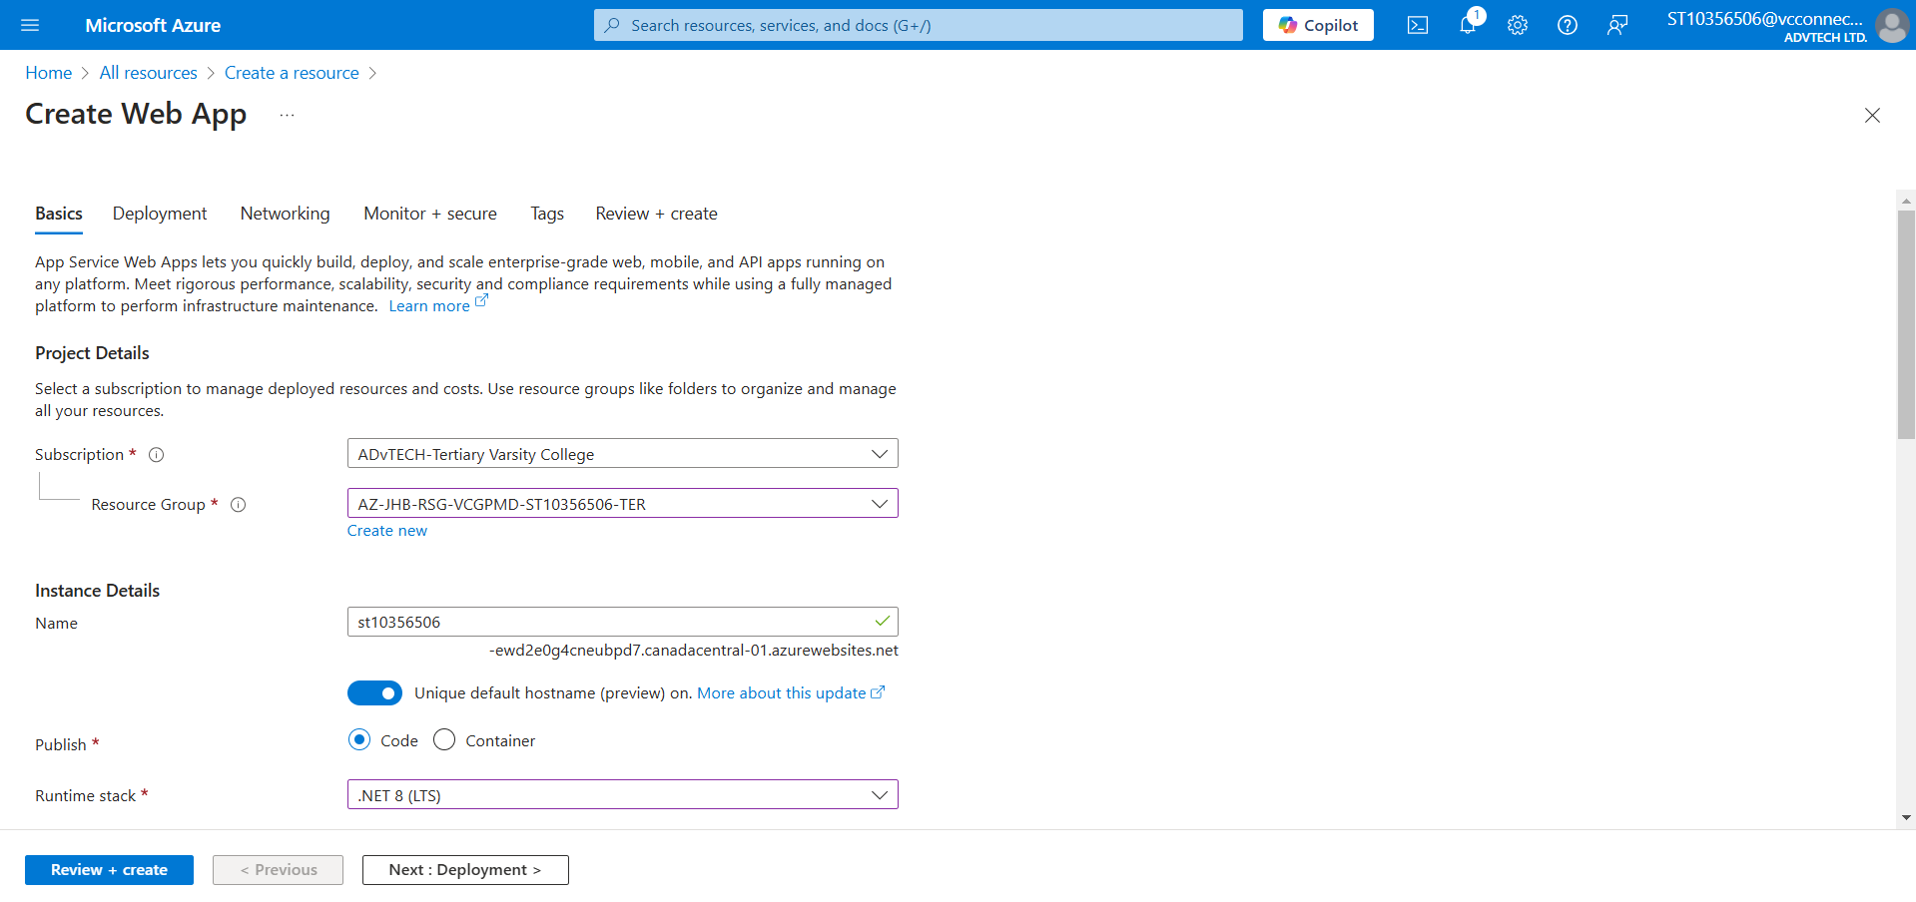**

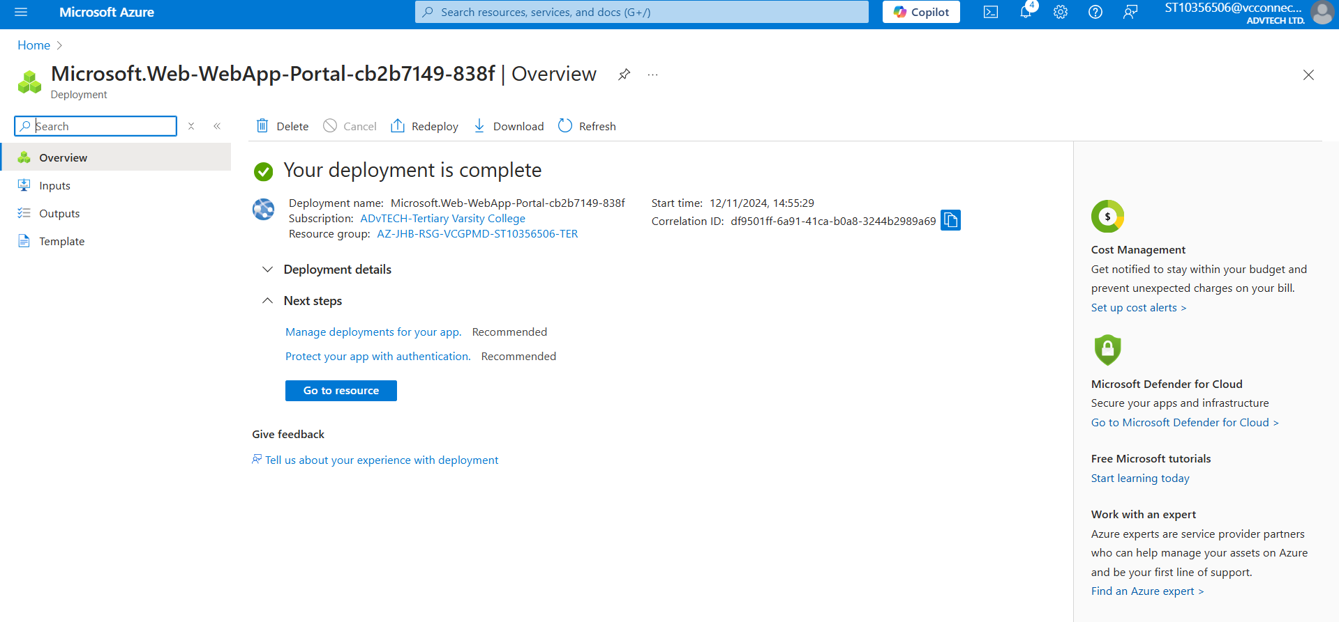

**Deploying the web application**

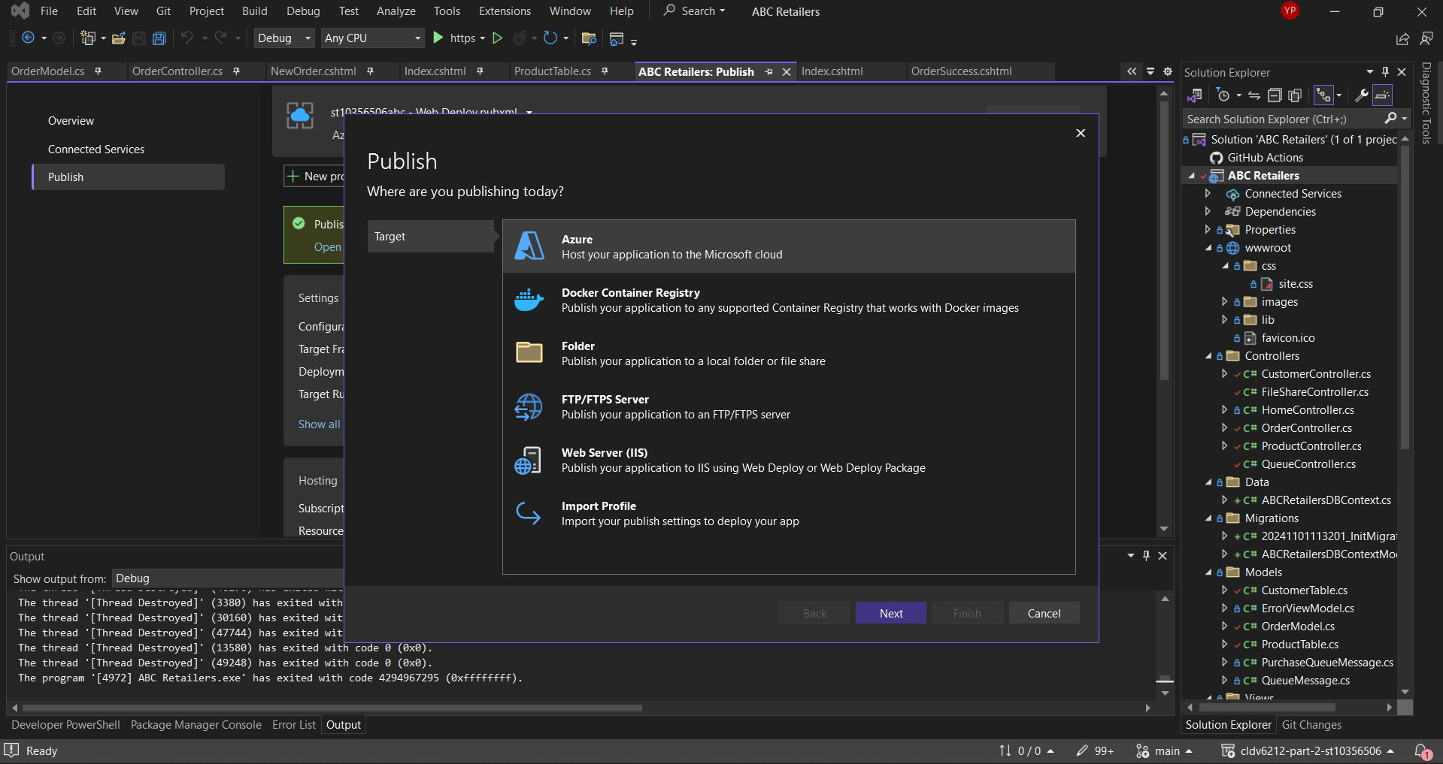

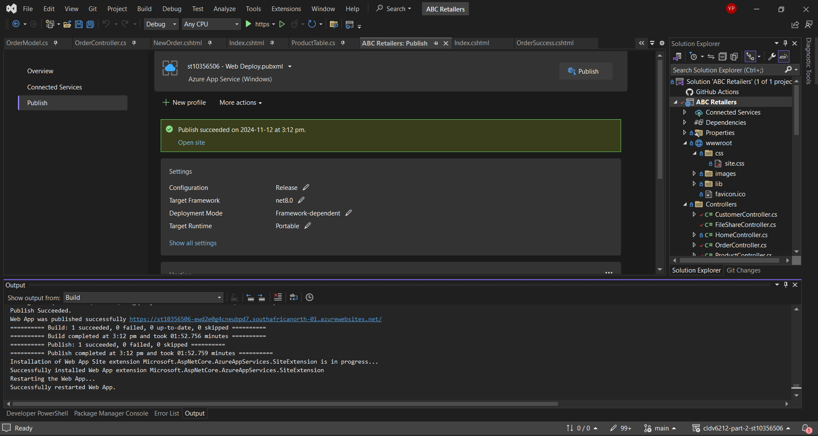

**Deployed application**

Website link: <https://st10356506-ewd2e0g4cneubpd7.southafricanorth-01.azurewebsites.net/>

Github link: <https://github.com/IIEWFL/cldv6212-poe-st10356506>

References

(No date) *Fast nosql key-value database – amazon dynamodb – AWS*. Available at: <https://aws.amazon.com/dynamodb/> (Accessed: 12 November 2024).

Adshead, A. (2020) *Cloud storage 101: NAS File Storage on AWS, Azure and GCP: Computer Weekly*, *ComputerWeekly.com*. Available at: <https://www.computerweekly.com/feature/Cloud-storage-101-NAS-file-storage-on-AWS-Azure-and-GCP#:~:text=and%20storage%20capacity.-,Google%20Cloud%20Platform,16MB%20to%20128MB%20per%20TB>. (Accessed: 12 November 2024).

*Azure blob storage vs google cloud storage: Which tool is better for your next project?* (no date) *azure blob storage vs google cloud storage: Which Tool is Better for Your Next Project?* Available at: <https://www.projectpro.io/compare/azure-blob-storage-vs-google-cloud-storage> (Accessed: 12 November 2024).

Biqian (2024) *How to enable geo-replication for Azure web pubsub*, *How to enable geo-replication for Azure Web PubSub | Microsoft Learn*. Available at: <https://learn.microsoft.com/en-us/azure/azure-web-pubsub/howto-enable-geo-replication> (Accessed: 12 November 2024).

*Category strategy - geo-replication* (no date) *GitLab*. Available at: <https://about.gitlab.com/direction/geo/geo_replication/#:~:text=Geo%2Dreplication%20will%20provide%20horizontal,about%20the%20underpinning%20Geo%20architecture>. (Accessed: 12 November 2024).

Joshi, U. and Dutta, J. (2023) *Differences to expect when migrating from azure cosmos DB to Amazon dynamodb | AWS database blog*. Available at: <https://aws.amazon.com/blogs/database/differences-to-expect-when-migrating-from-azure-cosmos-db-to-amazon-dynamodb/> (Accessed: 12 November 2024).

Kabharati (2024) *Geo-replication - azure database for PostgreSQL - Flexible Server*, *Geo-replication - Azure Database for PostgreSQL - Flexible Server | Microsoft Learn*. Available at: <https://learn.microsoft.com/en-us/azure/postgresql/flexible-server/concepts-read-replicas-geo#:~:text=A%20read%20replica%20can%20be,Microsoft%20Azure%20operated%20by%2021Vianet>. (Accessed: 12 November 2024).

Marget, A. (2024) *Geo-redundancy: Why is it so important?*, *Unitrends*. Available at: <https://www.unitrends.com/blog/geo-redundancy#:~:text=Organizations%20today%20face%20several%20challenges,a%20robust%20business%20continuity%20strategy>. (Accessed: 12 November 2024).

Mark (2024a) *Azure blob storage vs. Google Cloud Storage?*, *SmiKar*. Available at: <https://www.smikar.com/azure-blob-storage-vs-google-cloud-storage/#:~:text=Google%20Cloud%20Filestore%20vs%20Azure,applications%20that%20require%20SMB%20protocol>. (Accessed: 12 November 2024).

Mark (2024b) *Azure blob storage vs. Google Cloud Storage?*, *SmiKar*. Available at: <https://www.smikar.com/azure-blob-storage-vs-google-cloud-storage/#:~:text=Google%20Cloud%20Filestore%20offers%20high%2Dperformance%2C%20fully%2Dmanaged%20NFS,for%20legacy%20applications%20that%20require%20SMB%20protocol>. (Accessed: 12 November 2024).

Perry, M. (2023) *GCP vs. azure: Choosing the Best Cloud Provider for your needs*, *Qovery RSS*. Available at: <https://www.qovery.com/blog/gcp-vs-azure-choosing-the-best-cloud-provider-for-your-needs/#:~:text=Allows%20file%20share%20creation%20and,Azure%20Block%20Storage> (Accessed: 12 November 2024).

Prakash, A. (2023) *Cloud Data Storage Deep Dive: S3, GCS, and Azure Blob Storage compared*, *Airbyte*. Available at: <https://airbyte.com/data-engineering-resources/s3-gcs-and-azure-blob-storage-compared#:~:text=Amazon%20S3.%20S3%20is%20designed%20to%20handle,to%20provide%20fast%20and%20efficient%20data%20access>. (Accessed: 12 November 2024).

Rajeshsetlem (2024) *Active geo-replication - azure SQL database*, *Azure SQL Database | Microsoft Learn*. Available at: <https://learn.microsoft.com/en-us/azure/azure-sql/database/active-geo-replication-overview?view=azuresql#:~:text=Geo%2Dreplication%20provides%20regional%20redundancy,continuity%20with%20Azure%20SQL%20Database>. (Accessed: 12 November 2024).

Spelluru (2024) *Overview of features - azure event hubs - azure event hubs*, *Overview of features - Azure Event Hubs - Azure Event Hubs | Microsoft Learn*. Available at: <https://learn.microsoft.com/en-us/azure/event-hubs/event-hubs-features#:~:text=From%20the%20perspective%20of%20cost%2C%20operational%20effort%2C,to%20Kafka%2Das%2Da%2DService%20offerings%20not%20native%20to%20Azure>. (Accessed: 12 November 2024).

Williams, A. (2021) *8 best Amazon S3 Alternatives in 2021*, *8*. Available at: <https://inclowdz.wondershare.com/cloud-transfer/amazon-s3-alternative.html#:~:text=Google%20Cloud%20is%20Google’s%20direct%20alternative%20to,is%20a%20full%2Dspectrum%20alternative%20to%20Amazon%20S3>. (Accessed: 12 November 2024).

Akashdubey-Ms (2022) *Introduction to table storage - object storage in Azure*, *Introduction to Table storage - Object storage in Azure | Microsoft Learn*. Available at: <https://learn.microsoft.com/en-us/azure/storage/tables/table-storage-overview> (Accessed: 12 November 2024).

Akashdubey-Ms (2023) *Introduction to blob (object) storage - azure storage*, *Introduction to Blob (object) Storage - Azure Storage | Microsoft Learn*. Available at: <https://learn.microsoft.com/en-us/azure/storage/blobs/storage-blobs-introduction> (Accessed: 12 November 2024).

*Filestore: Fully managed cloud file storage | google cloud* (no date) *Google*. Available at: <https://cloud.google.com/filestore/> (Accessed: 12 November 2024).

Khdownie (2023) *Introduction to azure files*, *Introduction to Azure Files | Microsoft Learn*. Available at: <https://learn.microsoft.com/en-us/azure/storage/files/storage-files-introduction> (Accessed: 12 November 2024).

Msangapu-Msft (2024) *Overview of Azure App Service - Azure App Service*, *Overview of Azure App Service - Azure App Service | Microsoft Learn*. Available at: <https://learn.microsoft.com/en-us/azure/app-service/overview> (Accessed: 12 November 2024).

Normesta (2023) *Introduction to azure queue storage - azure storage*, *Introduction to Azure Queue Storage - Azure Storage | Microsoft Learn*. Available at: <https://learn.microsoft.com/en-us/azure/storage/queues/storage-queues-introduction> (Accessed: 12 November 2024).

WilliamDAssafMSFT (2024) *What is the Azure SQL database service? - azure SQL database*, *What is the Azure SQL Database service? - Azure SQL Database | Microsoft Learn*. Available at: <https://learn.microsoft.com/en-us/azure/azure-sql/database/sql-database-paas-overview?view=azuresql> (Accessed: 12 November 2024).

Yifat Perry, T.C.M. (2021) *Azure vs google cloud: How they compare*, *NetApp BlueXP*. Available at: <https://bluexp.netapp.com/blog/azure-vs-google-cloud-how-they-compare#:~:text=Summary:%20Azure%20provides%20a%20well,and%20ease%20of%20its%20use>. (Accessed: 12 November 2024).